Name
Professor
Title
Date []
Environmental Toxicity and Environmental Tobacco Smoke and Lung Development Activity
Background Information
Environmental tobacco smoke (ETS) and correlated toxicity have been linked to utmost respiratory ailments. Some of these diseases include asthma, middle ear infections, lung cancer and reduced functionality of lungs. According to specialists, close to 50% of children below the age of five are in one way or another exposed to passive tobacco smoking causing complex respiratory tract infections, bringing forth ailments, (Arizona, 1997). In this experiment, the focus will be on the effect of environmental tobacco smoke (ETS), on the development of lungs of mice pups.
Research Question: What are the effects of environmental toxicity and environmental tobacco smoke on the development of the lungs?
Hypothesis: Exposure of pregnant beings to tobacco smoke, affects the growth and development of the offspring’s’ lungs.
Independent Variables: Environment Tobacco Smoke and Time.
Dependent Variables: Exposed pregnant female mice and mice pups. (Experimental)
Control Variable: Non-exposed pregnant female mice and mice pups.
Materials
Two groups of Mice, a Simulated ETS, Lung tissue samples, epoxy plastic, stain, and microscope
Procedure
The experimental group, female mice were exposed to an environment tobacco smoke for 1 hour every day, for 5 days per week until the mice gave birth. After birth, we exposed the mice pups to ETS for 1 hour every day, for 5days every week for 3 weeks. When the 3 weeks ended, we prepared lung tissue samples and embedded in an epoxy plastic. Thin slices were made on slides and stained for observation over a microscope. We estimated septal tissue volume in each slide using a grid laid over the lung tissue image, by counting each instance where a grid crosshair touches septal tissue. The technique is illustrated below. The results were later compared to that of the control group.
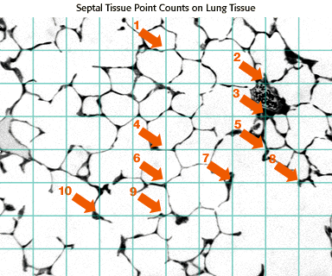
Results
Microscopic observation of Lung tissue sample of the experimental group
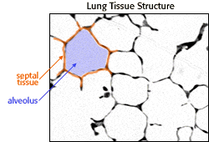
The number of Septa Tissue Points in the recommended 6 samples for both groups.
Sample 1 (Control)

12 Septa Tissues

Sample 2 (Experimental)
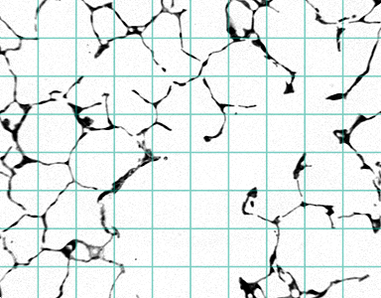
6 Septa Tissues

Sample 3 (Experimental)

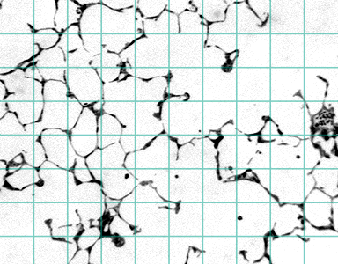
10 Septa Tissues

Sample 4 (Control)
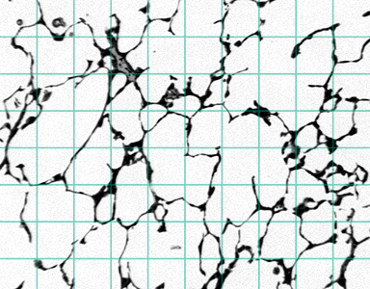
17 Septa Tissues
Sample 5 (Experimental)

4 Septa Tissues

Sample 6 (Control)
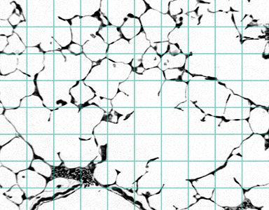
10 Septa Tissues

Control Group |  | Experimental Group
Slide | Count | Slide | Count
1 | 12 | 2 | 6
4 | 17 | 3 | 10
6 | 10 | 5 | 4
Mean | 10.3 | Mean | 6.7

Discussion
Hazardous Substances and their Sources
Dust Mite Parts, originates from dust mites living in beds, carpets, curtains, furniture.
Animal Dander comes from fur-bearing animals, such as dogs or cats.
Carbon Monoxide, sourced from broken appliances that incompletely burn natural gas or oil, such as furnaces or stoves.
Lead, mostly found in paint applied before 1978, batteries, water pipes.
Mercury, found in thermometers, filling in teeth, batteries
Tobacco Smoke comes from lighted cigarettes or cigars.
Mold Spores originates from molds which are found mostly in damp places like showers.
Sources of Error
Possibly from the data collected, we could have an error counting the septa tissue. The other possibility is that the experiment focused on 6 samples, in representing the 120 samples. This is a wide proportion thus the error magnitude could be great as well.
Conclusion
From the deduced results, we can agree with the hypothesis that environmental tobacco smoke upsets and damages lung morphology and development. The mice group exposed to cigarette smoke resulted in having less septal tissue than controls. Thus we can conclude that ETS exposed animals have less surface area in their lungs and possibly a reduced capability for gas exchange.
Work Cited
Arizona. The Biology Project. Chemicals and Human Health. http://www.biology.arizona.edu/chh/activities/tobacco_smoke/tobacco_smoke.html

Post Activity Research
Mycotoxins are any toxins produced by the fungus. They are capable of causing diseases and death in animals and humans. They infest in other crops as molds. They are several types of mycotoxins. They include; Aflatoxins, Ochratoxin, Trichothecene, Fumonisins, and Zearalenone. Aflatoxin is thought to be contaminating tobacco cigarettes, however, there is no established report of a relationship between growing tobacco leaves and aflatoxins (Kaminski et al 2013). The experiment conducted by Kaminski et al, (2013), tested for the presence of aflatoxins by TLC and spectrophotofluorometry in at least six smoking machine experiments. Surprisingly, there was no trace of aflatoxin B1 in any of the fractions examined. However, I believe the experiment being tested on a smoking machine would have been a source of error, considering decomposition and the cavity properties of a smoker.
Work Cited
Kaminski et al, 2013. The fate of Aflatoxins in Cigarette Tobacco.
DOI: 10.2478/cttr-2013-0235

